Introduction to Data Engineering
What is Data Engineering?
Data Engineering involves building systems and pipelines to collect, store, and analyze large volumes of data for downstream applications like analytics, ML, and reporting.
But why data engineering in first place?
What’s data? What is information?
Ex: 100, "John", 85 --- > “John scored 85 marks in Math”

Role in Data Ecosystem:
Data Engineers enable data scientists, analysts, and business users by ensuring clean, accessible, and timely data.
Data engineers, analyst, devops, mlops, data goverance, data scientists
Skills Required: - SQL and programming (Python, Scala) - Data pipeline tools (Airflow, Spark, Kafka) - Cloud platforms (AWS, Azure, GCP) - Databases (PostgreSQL, Snowflake, mysql, sql server)
Etl – informatica, datastage, adf , glue etc..

Data Engineering Lifecycle
- Data Collection - Gathering data from various sources.
- Ingestion - Moving data into centralized storage.
- Processing - Cleaning and transforming data.
- Storage - Storing raw and curated datasets.
- Analysis - Making data available for BI and ML.
- Consumption - Exposing data via APIs, reports.

Data Sources
- Databases: PostgreSQL, MySQL, MongoDB
- APIs: REST APIs (e.g., Google Maps, Payments)
- Files: CSV, JSON, XML
- Event Streams: Kafka, IoT Devices
- Web Scraping: Scrapy, BeautifulSoup
Example: Weather APIs, Payment Gateway logs, Rider/Driver DB in a cab service

Data Ingestion
Batch Ingestion: Periodic ingestion (e.g., daily logs)
Real-Time Ingestion: Streaming data (e.g., transactions)
Tools: - Apache NiFi: Drag-and-drop interface - Kafka: Distributed stream platform - Flume: Primarily for log data

ETL and ELT
ETL (Extract, Transform, Load): Traditional method
Flow:
Source System → ETL Tool → Transformed Data → Data Warehouse
Tools:
- Talend
- Informatica
- Apache Nifi
Best for:
- On-premise environments
- When transformation logic is complex and heavy
- Medium-small datasets
- Compliance-controlled environments (some prefer pre-transforming sensitive data)
Example Use Case:
A logistics company extracts shipment data from transactional systems, applies business rules (e.g., filter international shipments, convert time zones) in Talend, and loads it into Oracle DWH.

ELT (Extract, Load, Transform): Modern cloud-based method (used in BigQuery, Snowflake)
Flow:
Source System → Raw Data → Cloud DWH → SQL/dbt Transformation
Tools:
- dbt (very popular for ELT)
- Azure Synapse
- BigQuery SQL scripts
- Snowflake Tasks & Streams
Best for:
- Cloud-native environments (Snowflake, BigQuery, Redshift)
- Massive data volumes
- Faster and cheaper processing in cloud
- Schema-on-read flexibility
Example Use Case:
A ride-sharing app collects data from driver apps, rider apps, and payment systems. The raw data (JSON, CSV, SQL dumps) is dumped into Snowflake using Fivetran. Using dbt, transformation logic applies:

Data Storage
Relational Databases (RDBMS): PostgreSQL, SQL Server
NoSQL: MongoDB, Cassandra
Data Lakes: AWS S3, Azure Blob (for raw files)
Data Warehouses: Snowflake, BigQuery, Redshift

Data Processing
Batch Processing: Scheduled (Spark, Flink)
Stream Processing: Real-time (Kafka Streams)
Tools: - Apache Spark: General processing engine –
Apache Flink: High-performance stream processing –
Apache Beam: Unified batch + stream

Data Pipelines
Pipeline Design: - Modular and reusable components - Error handling, retries
Orchestration: - Using Airflow, Prefect, or Dagster to schedule and manage tasks
CI/CD for Pipelines: - Using GitHub Actions, Jenkins for deployment

Workflow Orchestration & Scheduling
Tools: - Airflow
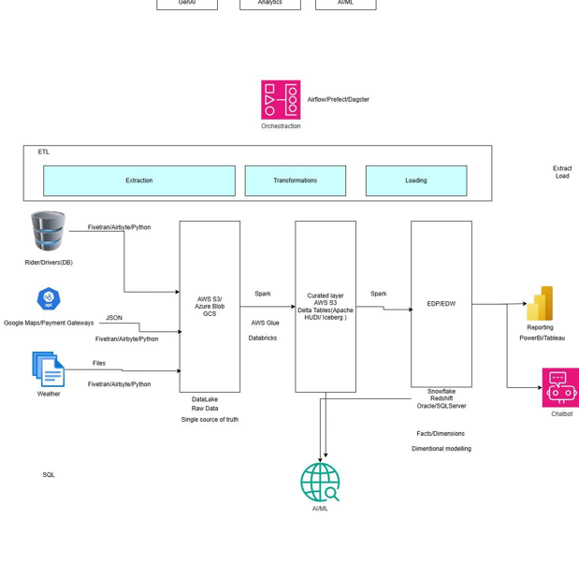

Big Data Ecosystem
- Hadoop: HDFS for storage, MapReduce for compute
- Hive: SQL on Hadoop
- HBase: NoSQL on Hadoop
- Spark: Unified engine
- Kafka: Distributed streaming

Hadoop:

What is it?
Hadoop is an open-source framework for storing and processing large volumes of data using distributed computing.

Components:
- HDFS (Hadoop Distributed File System)
  - Splits large files into blocks and stores them across multiple machines.
  - Ensures fault tolerance by replicating data.
- MapReduce
  - Programming model for processing data in parallel across machines.
  - Works in two steps:
    - Map: Break down data into key-value pairs.
    - Reduce: Aggregates or summarizes the mapped data.

[1,2,3,4,5,6] -> [x*2] -- [1, 4,9,16,25,36]

Reduce - [1, 4,9,16,25,36] - sum , avg, mean single -- > 91

Single command from user -- mapped with multiple distributed systems where data (map)chunked and split -- computation/opentations- output as single value(reduce )

Why was Hadoop Needed?
- Traditional databases struggle with big data (TBs or PBs).
- Hadoop provides scalability and fault tolerance using commodity hardware.
- It made big data processing affordable and distributed.

Hadoop vs Spark
Feature | Hadoop (MapReduce) | Spark
Processing | Disk-based (slower) | In-memory (faster)
Ease of Use | Requires Java coding | Easier APIs (Python, Scala)
Speed | Slower due to disk I/O | Much faster with in-memory
Use Cases | Batch jobs | Batch + Real-time + ML

Cloud Platforms
AWS: - S3 (Storage), Glue (ETL), Redshift (DWH)
Azure: - Blob Storage, Synapse, Data Factory
GCP: - BigQuery, Dataflow, GCS

On-Premise Stack
- Hadoop ecosystem
- MySQL/PostgreSQL on servers
- Cron, Nifi for scheduling

Data Governance & Security
- Data Lineage: Track data origin and flow
- Cataloging: Tools like AWS Glue Catalog
- Masking & Encryption: Secure sensitive data

. Data Lineage = “Where did the data come from?”
Data Cataloging = “Index or Google for your data”

Tools like AWS Glue Data Catalog or Apache Atlas help:
- List all your data tables/files
- Show what each table/column means
- Who owns the data
- When it was last updated

Masking & Encryption = “Hide or lock the secret data”
- Masking: Hide sensitive data like phone numbers or credit card info.
  - Example: Show ****1234 instead of full card number
- Encryption: Lock the data so only authorized users can open/read it.
  - Like turning the data into a secret code

Data Quality & Testing
- Validation: Schema checks
- Great Expectations: Open-source data testing
- Unit Testing: pytest for Python ETL scripts

Data Visualization & Reporting
BI Tools: - Power BI - Tableau

Power BI
- Data Import
- Data Modeling
- DAX Measures
- Dashboard Design

Tableau
- Data Connections
- Custom Calculations
- Interactive Dashboards

Reporting Best Practices
- KPIs: Business-aligned metrics
- Automation: Scheduled refresh
- Storytelling: Insightful dashboards

Data Delivery & APIs
- Use Flask or FastAPI to expose data

Serving Data for ML/Analytics
Once your data is cleaned and transformed, it needs to be served (made available) for use in:
- Machine Learning models (training/predictions)
- Analytics and dashboards

Real-Time Data Engineering
Use Cases: - Fraud detection - Real-time pricing
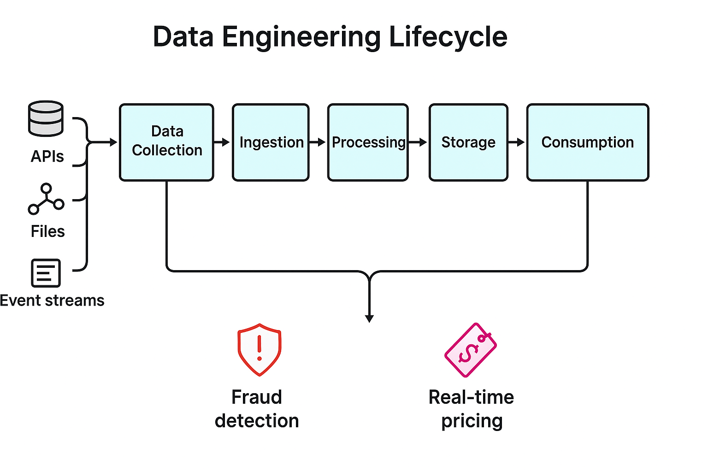

. Data Collection
- Event sources:
  - Payment Gateway APIs
  - Mobile App Logs (login attempts, payment behaviour)
  - IP addresses, device info
These events are generated in real-time as the user interacts with the system.

2. Ingestion
- Tools like Kafka or Kinesis stream the data immediately to the platform.
- Every transaction or user action becomes an event message pushed to a topic/queue.
Real-time ingestion ensures no delay.

3. Processing
- Spark Streaming or Flink picks up these events and applies:
  - Pattern matching (e.g., login from a new device + large payment)
  - Rule-based or ML-based anomaly detection
  - Time-windowed analysis (e.g., too many failed attempts in 10 mins)
Logic runs continuously — no need to wait for batch jobs.

4. Storage
- Suspicious events are stored in:
  - A real-time alerts table
  - NoSQL systems (Cassandra, DynamoDB) for fast read/write
  - Optionally pushed to Data Lake for historical training
Allows further ML model training or audit trail.

5. Consumption Layer
- Alerts are pushed to:
  - Fraud alert dashboard
  - Notification system (email/SMS) for fraud team
  - Model retraining workflows (feedback loop)
Fraud team can act in seconds — before the transaction completes

